LAB Assignment No 8
Smart Temperature & Humidity Monitoring System with ESP32 and ThingSpeak
In this lab, students will design and implement a basic IoT-based environmental monitoring system using an ESP32 microcontroller and a DHT22 sensor. The system will measure temperature and humidity in real time and apply simple decision logic to control an LED when predefined threshold values are exceeded. Additionally, sensor data will be transmitted to the cloud using ThingSpeak, where it can be visualized through live graphs.
This lab introduces students to key IoT concepts including sensor interfacing, wireless communication, cloud integration, and real-time data monitoring, forming a foundation for more advanced IoT applications.

Lab Objectives
- To interface DHT22 sensor with ESP32
- To monitor temperature and humidity in real time
- To control an LED based on threshold conditions
- To send sensor data to ThingSpeak cloud
- To visualize IoT data using cloud graphs

Learning Outcomes
After completing this lab, students will be able to:
- Understand sensor interfacing with ESP32
- Implement conditional logic in embedded systems
- Use WiFi for IoT communication
- Send data to cloud using ThingSpeak API
- Analyze real-time data using cloud visualization
- Build a complete end-to-end IoT system

Required Hardware
- ESP32 Development Board
- DHT22 Temperature & Humidity Sensor
- LED
- 220Ω Resistor
- Breadboard & Jumper Wires
Required Software / Simulation
- Arduino IDE
- Wokwi Simulator
- ThingSpeak Account

Circuit Diagram

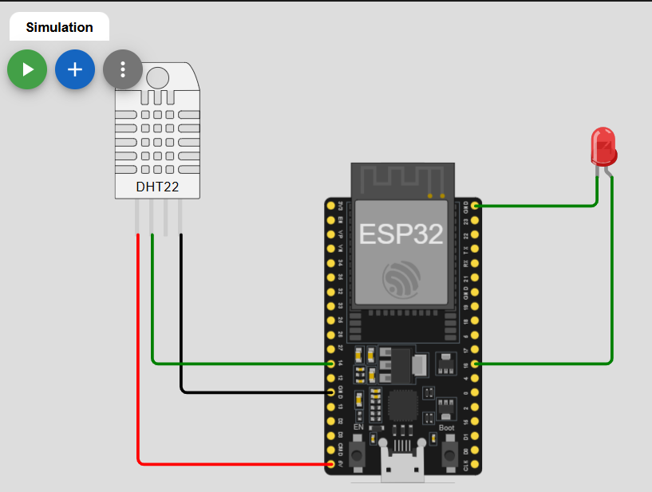

ThingSpeak Setup
- Create an account on ThingSpeak
- Create a new Channel
- Add fields:
  - Field 1 → Temperature
  - Field 2 → Humidity
- Copy:
  - Channel ID
  - Write API Key
Program Code
#include <WiFi.h>
#include <ThingSpeak.h>
#include "DHT.h"

// Channel details
unsigned long channelID = 3365699;
const char* writeAPIKey = "4O1QPV6ZU8S8KB8C";

// WiFi client
WiFiClient client;

// DHT setup
#define DHTPIN 14
#define DHTTYPE DHT22
#define LED_PIN 16

DHT dht(DHTPIN, DHTTYPE);

// WiFi credentials (Wokwi default)
const char* ssid = "Wokwi-GUEST";
const char* password = "";

// Threshold values
float tempThreshold = 30.0;
float humThreshold = 60.0;

void setup() {
Serial.begin(115200);

pinMode(LED_PIN, OUTPUT);
digitalWrite(LED_PIN, LOW);

dht.begin();

// Connect WiFi
WiFi.begin(ssid, password);
Serial.print("Connecting to WiFi");

while (WiFi.status() != WL_CONNECTED) {
delay(500);
Serial.print(".");
}

Serial.println("\nConnected!");

// Initialize ThingSpeak
ThingSpeak.begin(client);
}

void loop() {
float temperature = dht.readTemperature();
float humidity = dht.readHumidity();

if (isnan(temperature) || isnan(humidity)) {
Serial.println("Failed to read from DHT sensor!");
return;
}

Serial.print("Temp: ");
Serial.print(temperature);
Serial.print(" °C | Humidity: ");
Serial.print(humidity);
Serial.println(" %");

// LED Control Logic
if (temperature > tempThreshold || humidity > humThreshold) {
digitalWrite(LED_PIN, HIGH);
Serial.println("⚠️ ALERT: LED ON");
} else {
digitalWrite(LED_PIN, LOW);
Serial.println("✅ Normal: LED OFF");
}

// Send data to ThingSpeak
ThingSpeak.setField(1, temperature);
ThingSpeak.setField(2, humidity);

int response = ThingSpeak.writeFields(channelID, writeAPIKey);

if (response == 200) {
Serial.println("Data successfully sent to ThingSpeak");
} else {
Serial.print("Error sending data. HTTP code: ");
Serial.println(response);
}

// ThingSpeak requires 15 seconds delay
delay(15000);
}

Working Principle
- ESP32 reads data from DHT22
- Compares values with threshold:
  - Temp > 30°C
  - Humidity > 60%
- If condition TRUE → LED ON
- Data is sent to ThingSpeak every 15 seconds
- Graph is updated in real-time

Wokwi Simulation
📷 Expected Simulation Output
👉 Students should observe:
- Serial monitor showing values
- LED turning ON/OFF
- Sensor values changing

ThingSpeak Output
📊 Expected Cloud Output
👉 Students should observe:
- Temperature graph
- Humidity graph
- Real-time updates
LAB Tasks:
Students are required to:
✅ Task 1
Implement ESP32 + DHT22 interfacing
✅ Task 2
Apply LED control logic based on threshold
✅ Task 3
Send data to ThingSpeak cloud
✅ Task 4
Verify cloud graphs
✅ Task 5 (Extension)
Change threshold values and observe behavior

Deliverables
Students must submit:
- Source code
- Screenshot of Wokwi simulation
- Screenshot of ThingSpeak graphs
- Short explanation (1–2 pages)

Viva Questions
- What is DHT22 sensor?
- Difference between DHT11 and DHT22
- What is IoT cloud?
- Why delay is required in ThingSpeak?
- What is API key?
- Difference between HTTP and MQTT
- How ESP32 connects to WiFi?
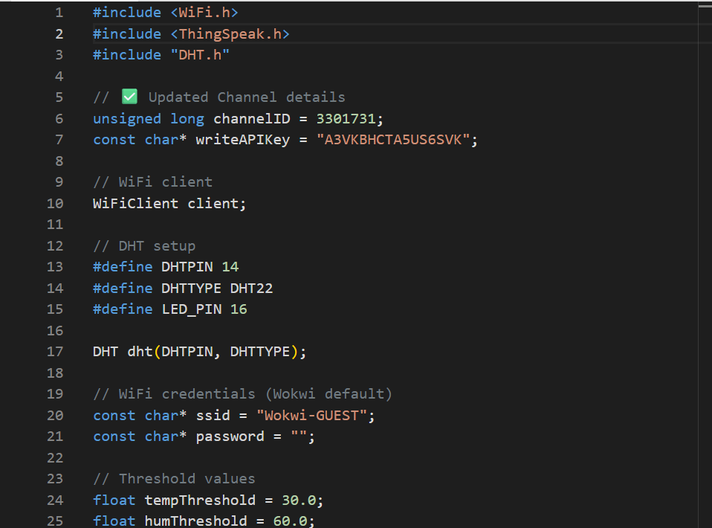
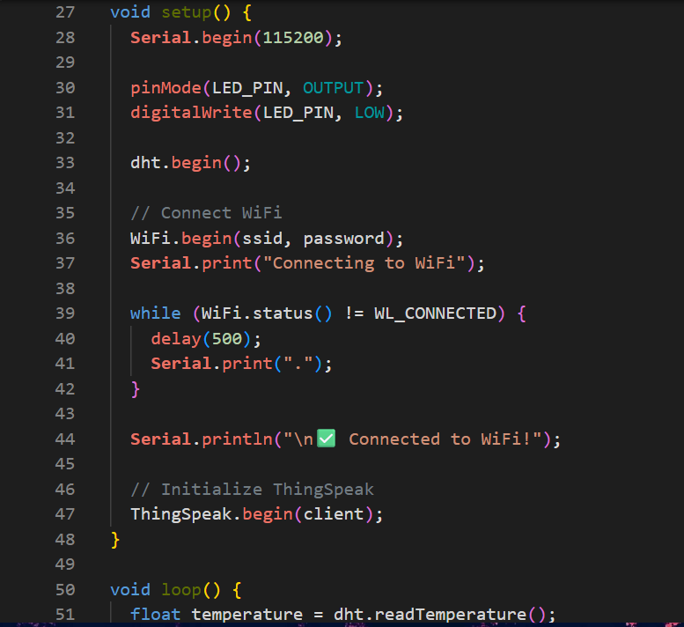
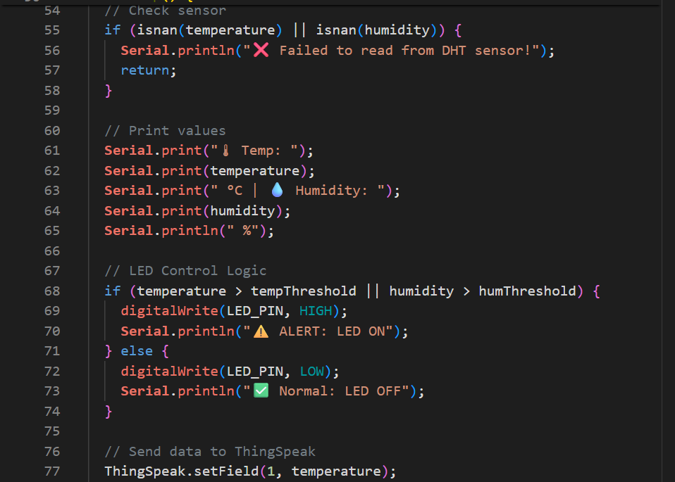
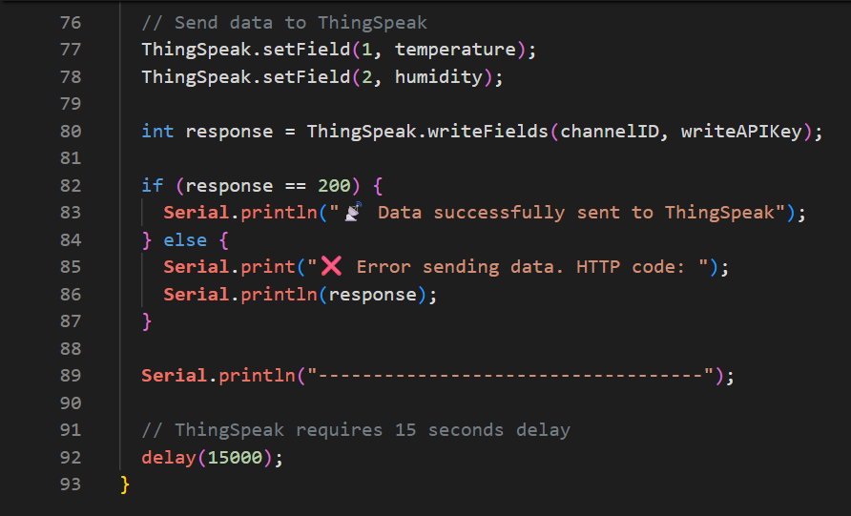
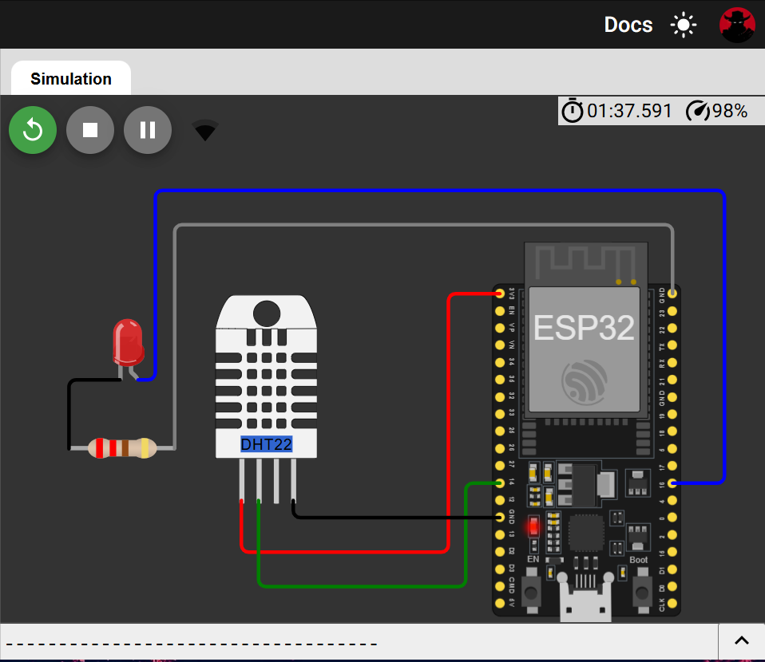

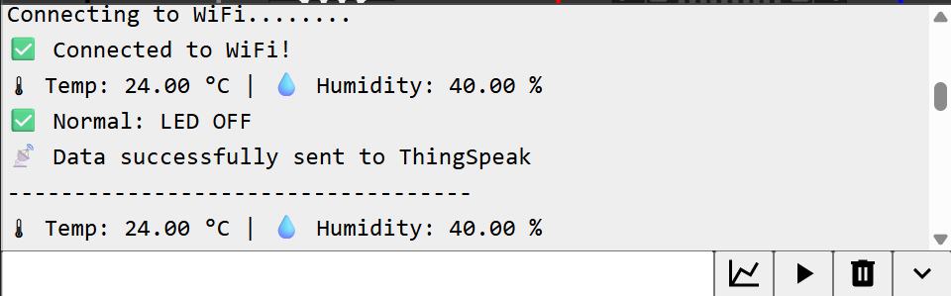
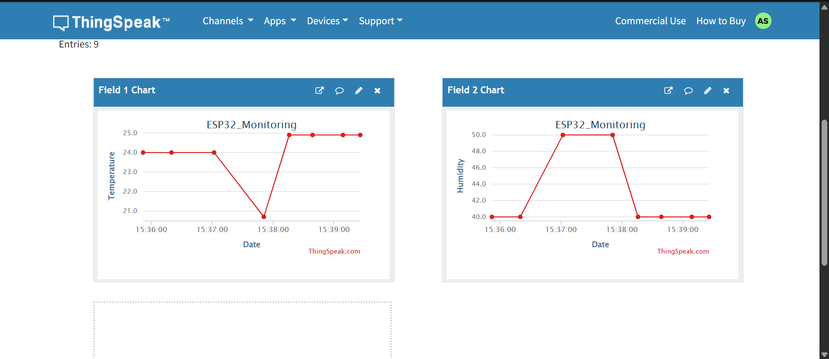
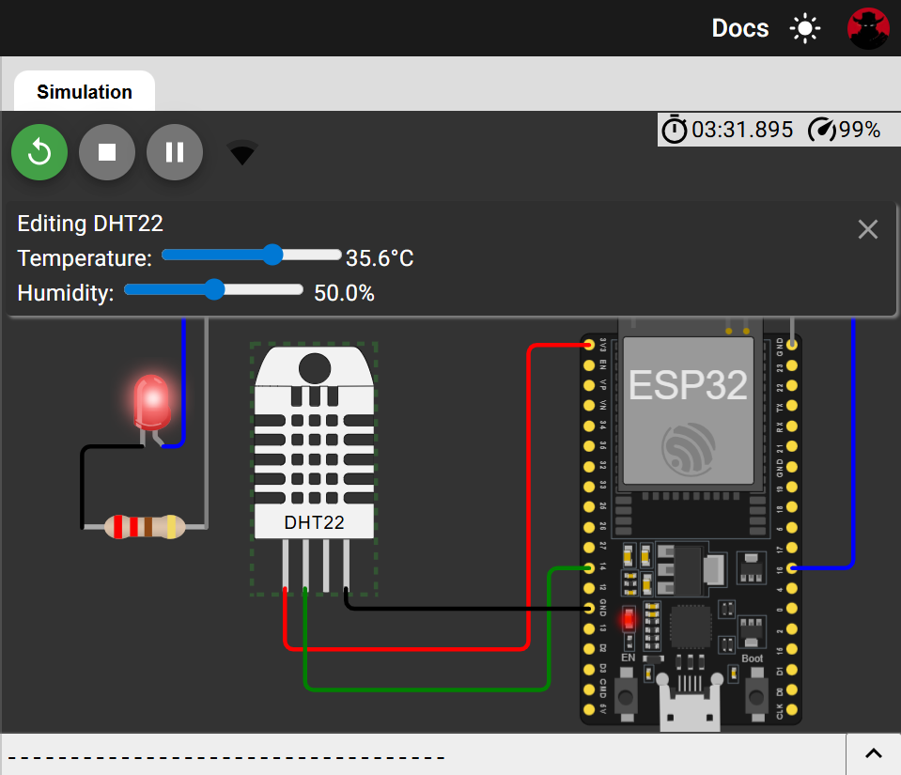
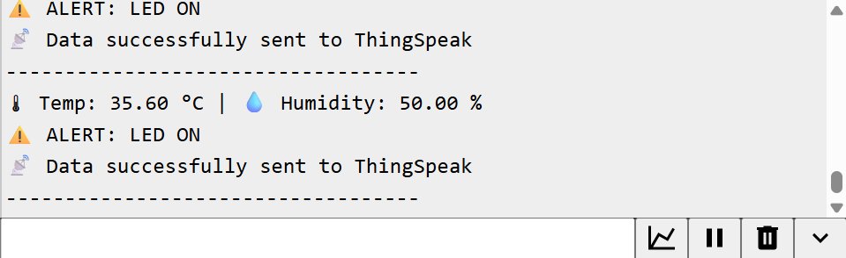
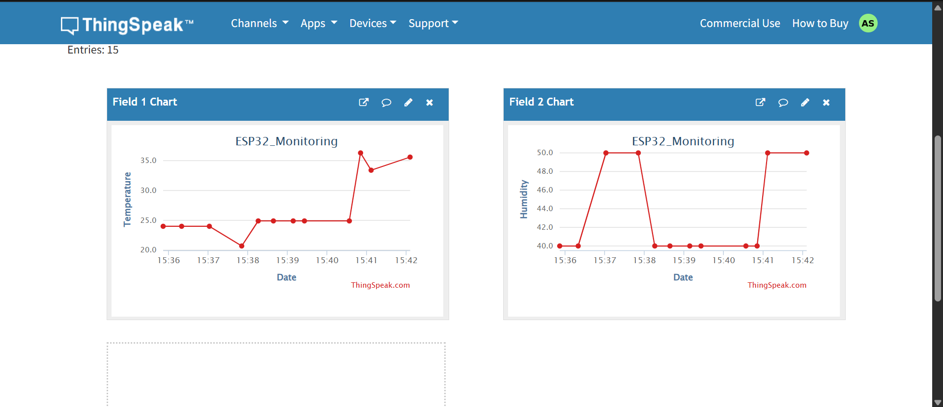
LAB Assessment

Student Name |  | LAB Rubrics | CLO3, P5, PLO5
 |  | Total Marks | 10
Registration No |  | Obtained Marks
 |  | Teacher Name | Dr. Syed M Hamedoon
Date |  | Signature

